**CCC Heep Woh College**

Hero UponGreat Fire

Supervisor : 　　　　　　　　　　 Team member:　　　　　　　　　　  
Mr. Hsia Ming Wai　　　　　　　　Mak Kin Wing　　　　　　　　　　　　　　　  
　　　　　　　　　　　　　　　　Lam Ka Chun  
　　　　　　　　　　　　　　　　Leung Ho Kwan

Content

Idea 3

Concept of System 4

Component……………………………………………………………………………………………………………….5  
 - Energy source prospecting process……………………………………………………………..….6  
 - Energy source collecting process…………………………………………………………………….7

Mechanic Design……………………………………………………………………………………..……………….8

　- Prospector……………………..……………………………………………..………………………………..8

　　-Base……..……………………………………………………………………………………………………….10

　　- Collector…………………………………………………………………………….…………………………12

Program Design………………………………………………………………………………………………….…..15

- Base…………………………………………………………………………………………….….…………….15

- Prospector……………………………………………………………………………………….……………18

- Collector………………………………………………………………………………………….……………25

Idea

　　After the Industrial Revolution, the speed of advance technology development increase. The reason why because of the satisfactory material on our Earth. Nevertheless, under the larger demand of energy, scientists estimated that the energy source such as patrol and natural gases will be used up in the recently several ten year. Therefore, the energy problem become more and more important and many countries started to aware of it. Some alternative energy use such as solar and wind are also used.   
  
　　However, the renewable energy is limited while many countries still use some non-renewable energy as the main energy supply. Some historical accident such as nuclear power accident tell us the energy crisis still here in our life.   
  
　　As a result, many scientists turn their focus from Earth to Universe. There are many planets that are judged as suitable for living by human. Also there is many new energy source in other planet that can be used as energy. Such as the Jupiter, there is a lot of sulphur for energy use. These kind of energy source will not emit any poison substances. We called them perfect energy.   
  
　　In short, our team had produced a series of system that can prospect the energy source and with the cooperation with other machine automatically , it can collect the energy source . We hope our idea can help our human world.

Concept of System

**Concept briefing:**

When Prospector find the energy source, it will pass the data of displacement to the base, after a string of calculation , base will adjust the initial angle of collector. Afterward, Collector will run and at the same time put down the railway in order to run on the railway. Later the Collector will collect the energy source and then recycle back the railway.

**Mechanics :**

**Prospector**

**Prospect the surface of planet, when find the energy source, after calculation of rotation, it can automatically position back to the base**

**Feature**

* Equippedwith suspension system in order to increase the stability of Prospector, expand the life expectancy.
* Programed with automatic-positioning system，strengthen the communication between machines

**Collector**

After receiving the displacement data, further adjust the initial angle of collector. Using the method of railway to collect the energy source and finally recycle the railway.

**Feature**

* Railway can be recycled and can be reused.
* The stability can be increasedue to the railway
* Collector can directly go and back from the base, increase the efficiency.

Component

**Energy source prospecting process**

Program Interpretation : This program control the prospector, when prospector go outside the planet surface, it will run as “Z” shape and prospect whether there is any energy source. Prospector will stop and back to the base when it sense energy source. Also prospector will save the data of the rotation of the two motor of the prospector in order to calculate the path difference so that prospector can back to the base successfully.

**Mechanics**

Equipped with suspensionsystem, it can let the Prospector run on different attitude surface.

**Programming**

Prospector go outside the planet surface, it will run as “Z” shape and prospect whether there is any energy source.

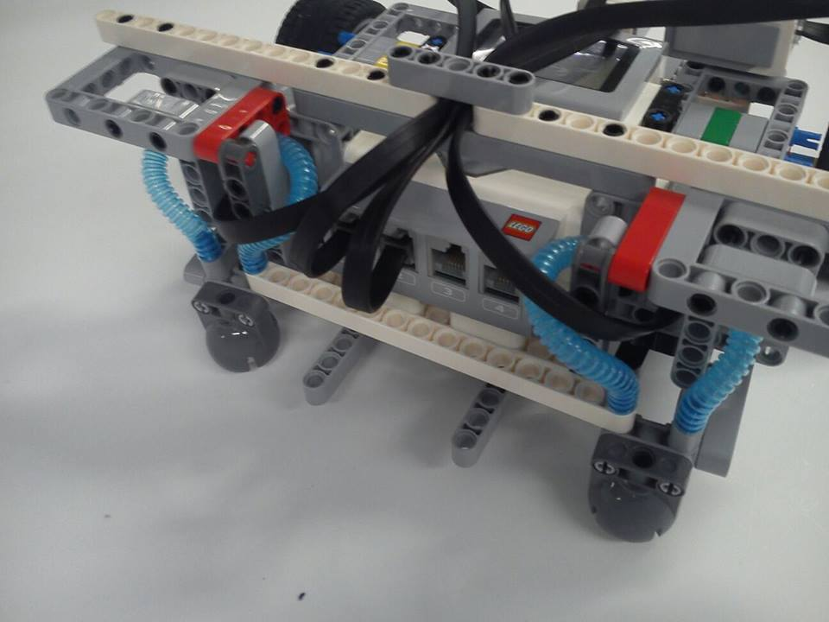

Suspension system

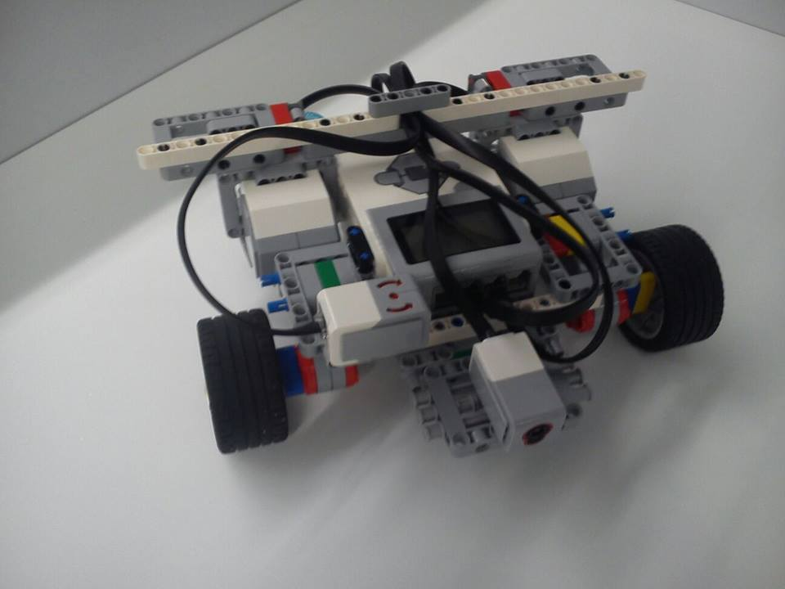

Whole Machine

**Energy source collecting process**

After receiving the information of the displacement from the Prospector, Base will calculate the tier difference between the Prospector and the Collector, also it will adjust the initial position of the collector according to the displacement data and using the trigonometric calculation. Collector will run and put down the railway at the same time. It will run on the railway and collect the energy source, after the collection of the energy source, it will recycle the railway back and the whole machine will back to base.

**Machine Design**

The front side of the Collector is a design that used for storing the railway and the recycle process.

**Program Design**

After the data that passed by the base, it has change to the new distant according to the collector’s tier. Afterward, collector run and collect the energy. Finally, Collector recycle the railway and back to the base.

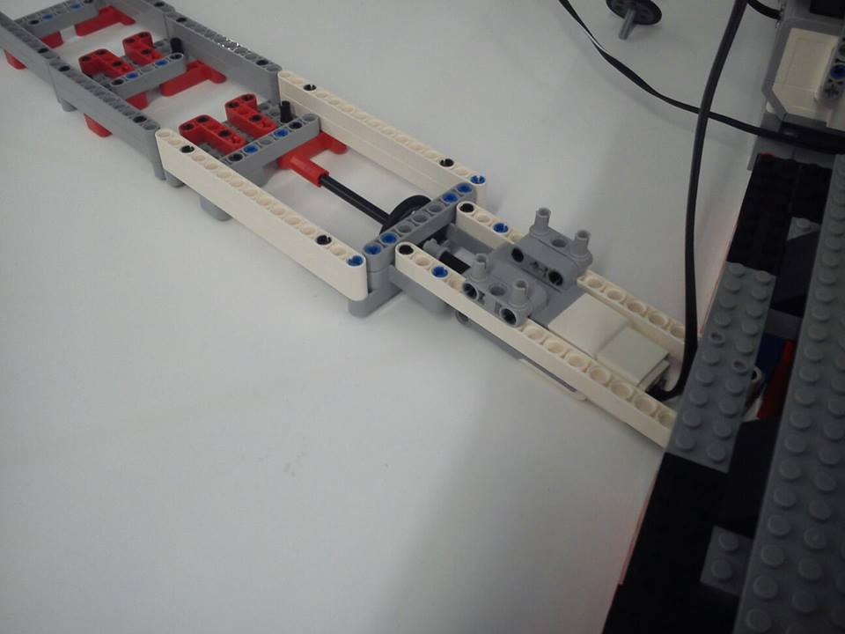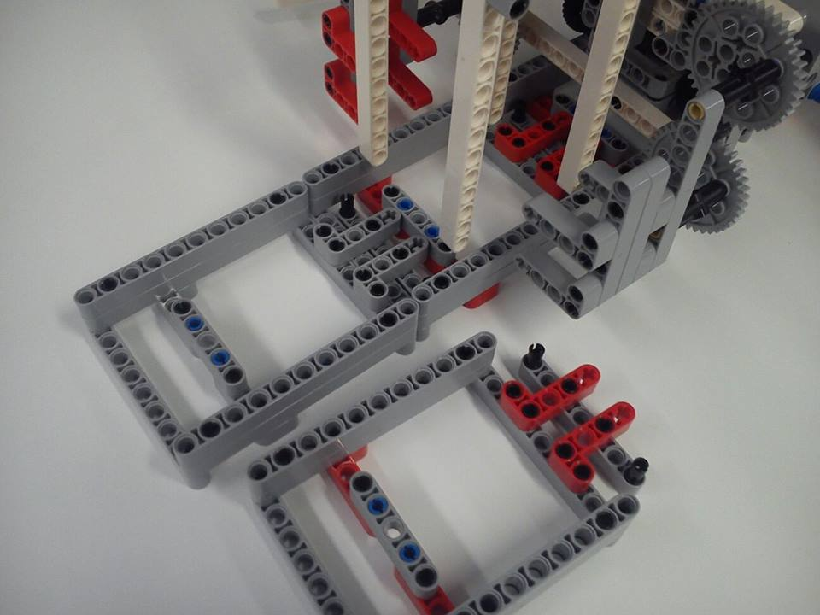

Railway and the adjustment component

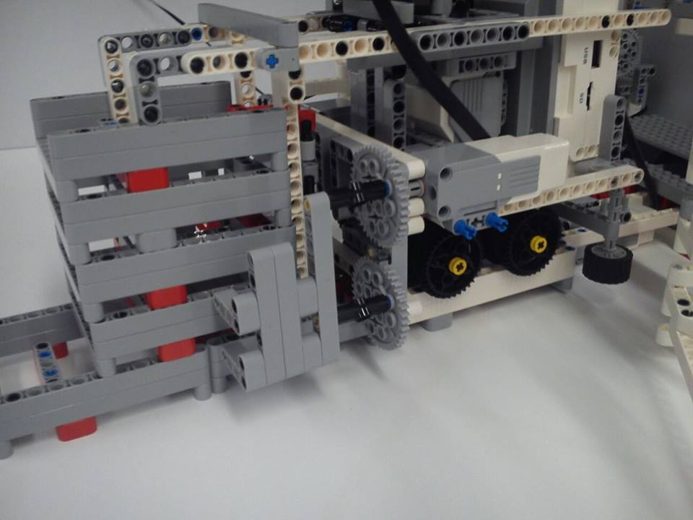

recycle and the storage of railway

**Mechanics Design**

**Prospector**

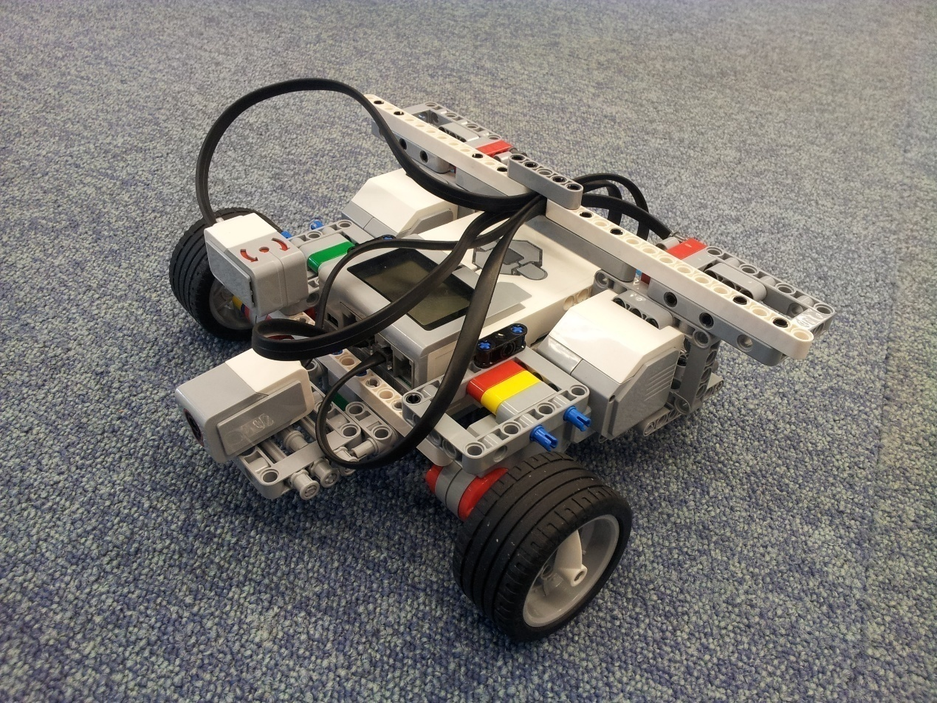

A sensor that used to sense the energy source is placed at the front

Suspension system behind the body of the Prospector is used to increase the ability of resisting the shaking

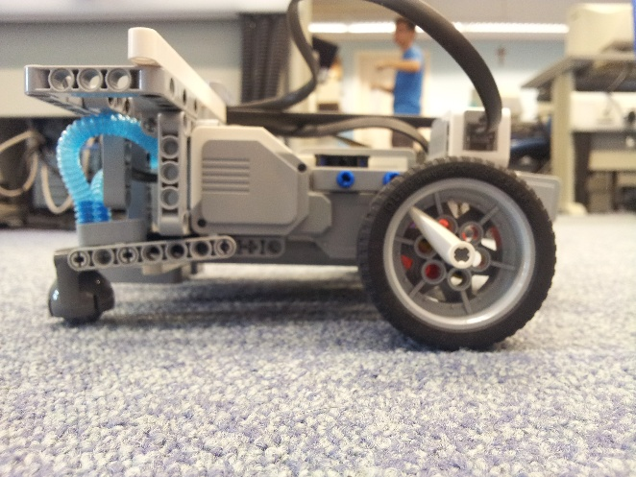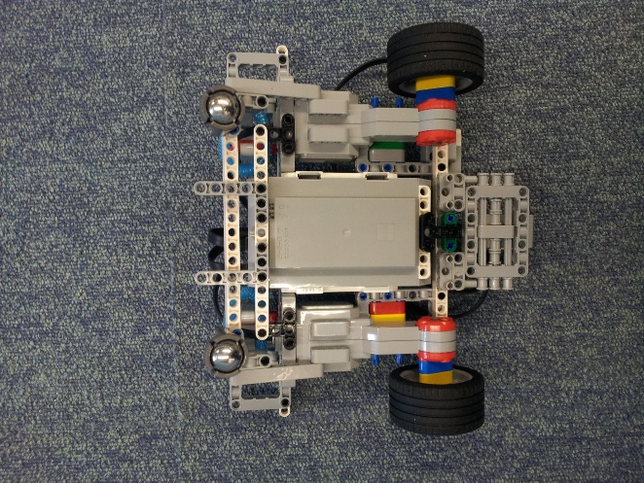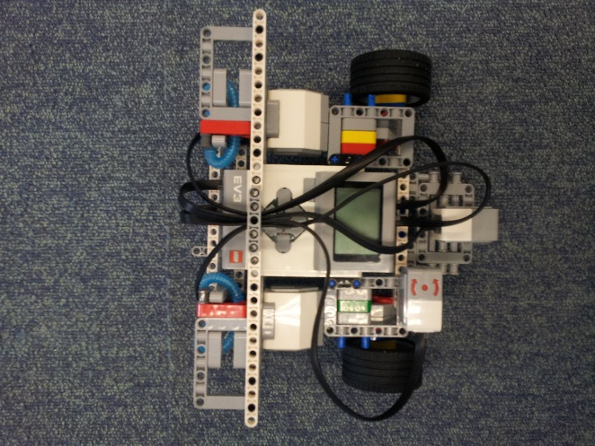  
Top view and the Bottom of Prospector  
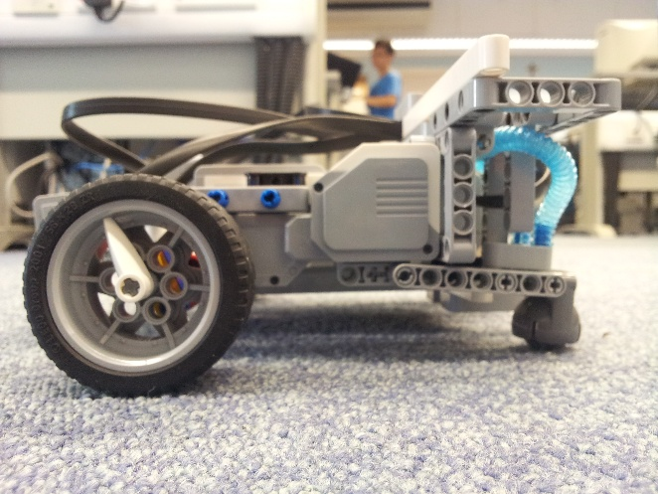

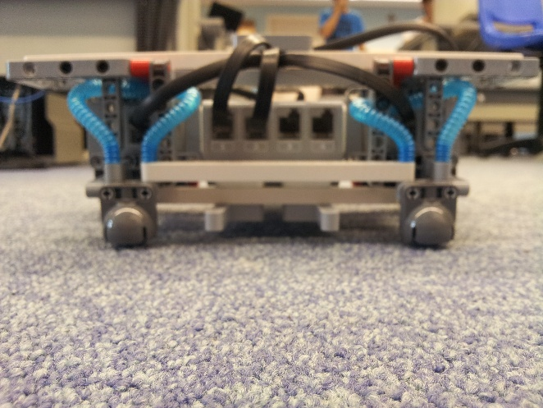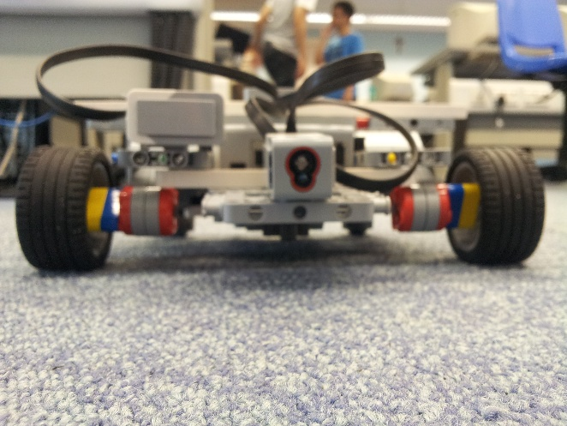Left and Right

Front and Behind

**Base**

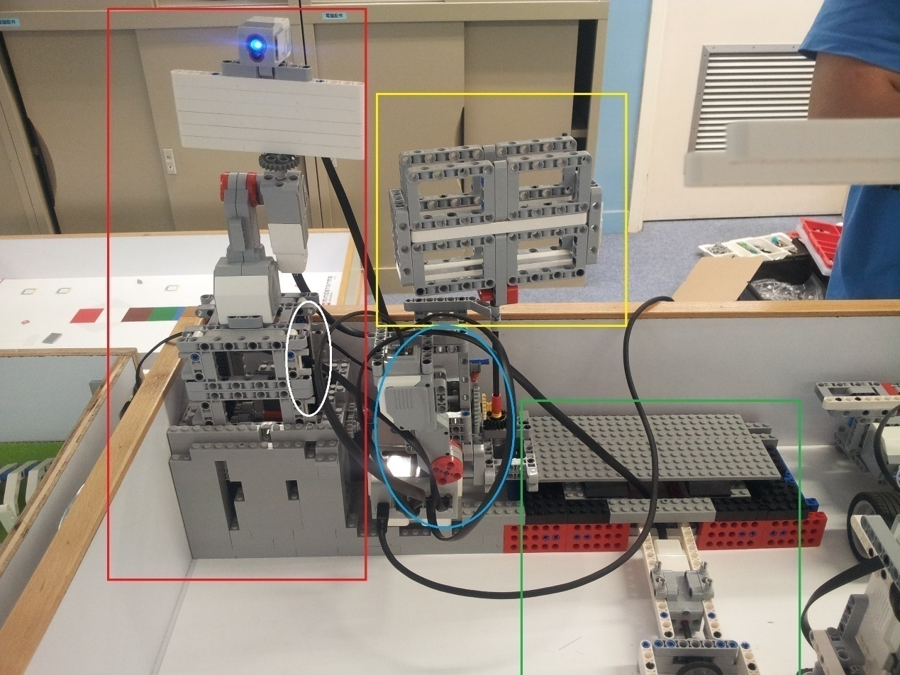

Base is connected with the adjustment terminator and the photographic area.

Beside, the up side down machine and the photographic area use a special equipment.

It is the **Single-Input, Double-Output system**

It ignore the limitation of LEGO EV3 and the complicated structure in this SIDO system is really creative.

The detail description will be introduced in the competition.

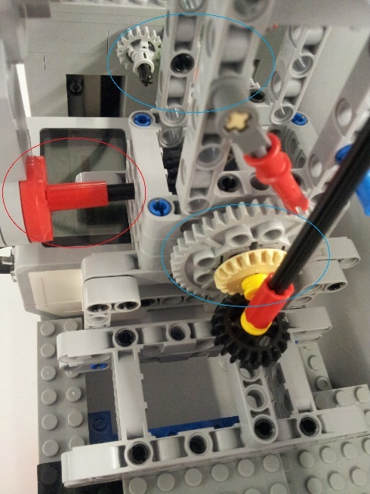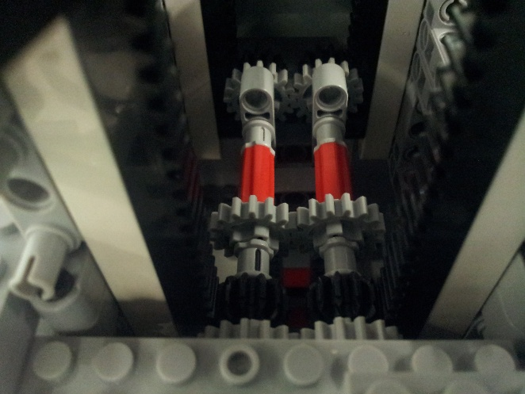

Solar panel inside

**Single-Input, Double-Output system**

**Anti-clockwise will be a output power**

**Clockwise will be another output power**

**But there is only one input power used**

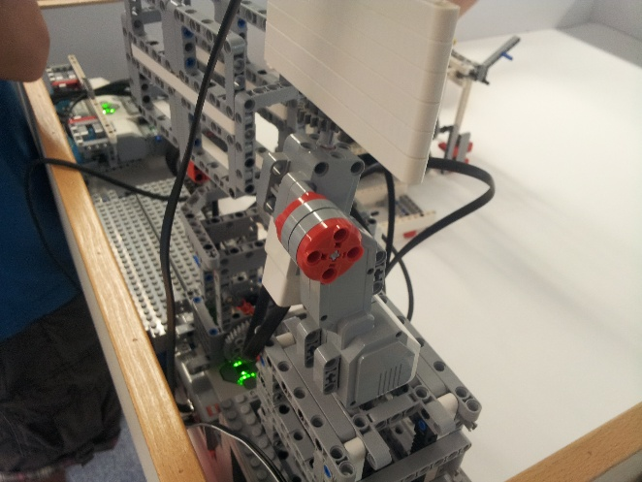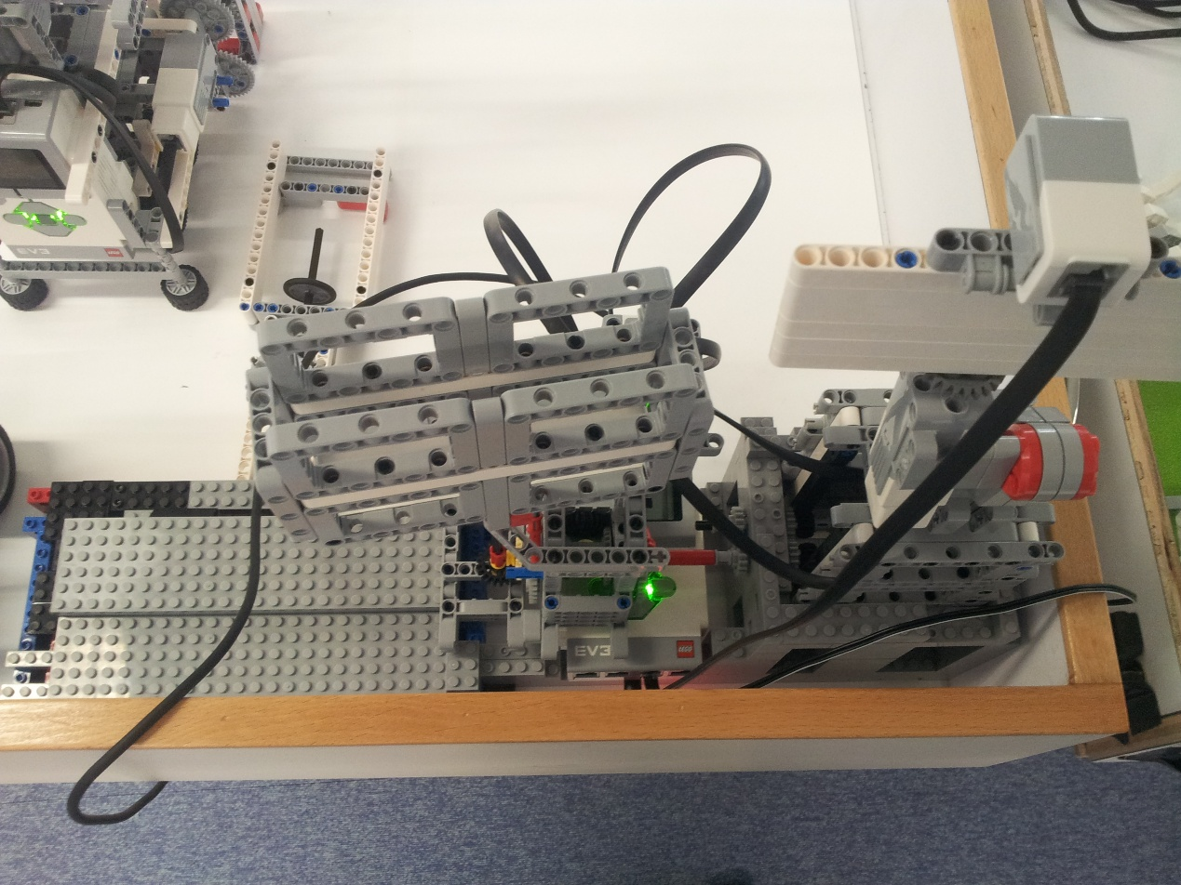

Top view of Base

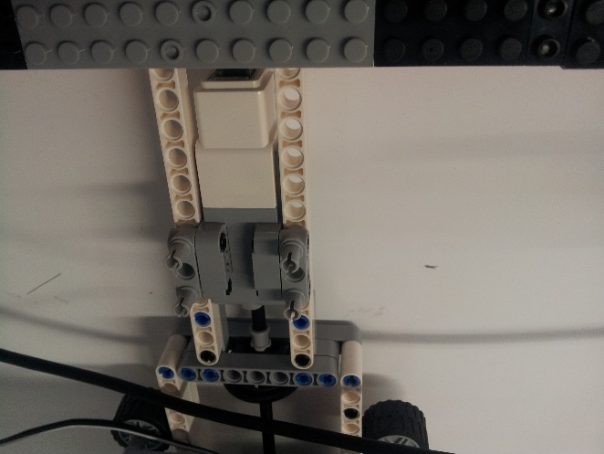

Adjustment system in order to adjust the initial angle for the Collector to go and start the mission

**Collector**

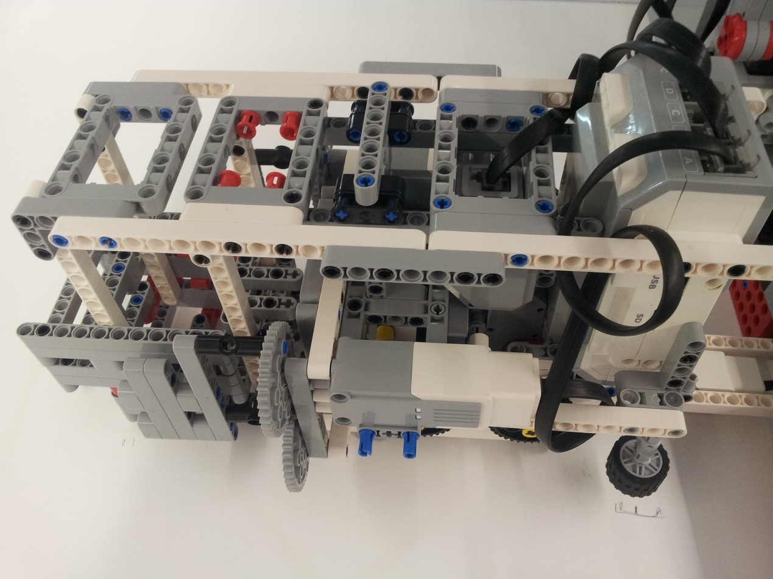Collector is operation on the railway

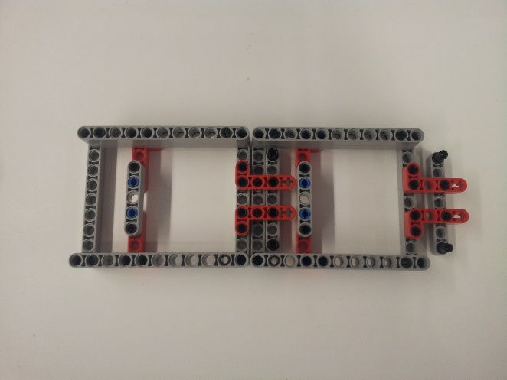

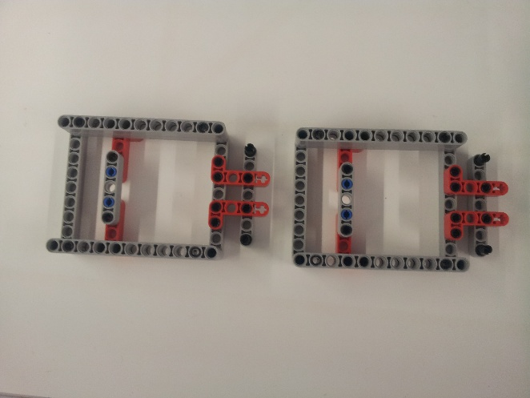

The railway can be put one by one which can be cocking together.

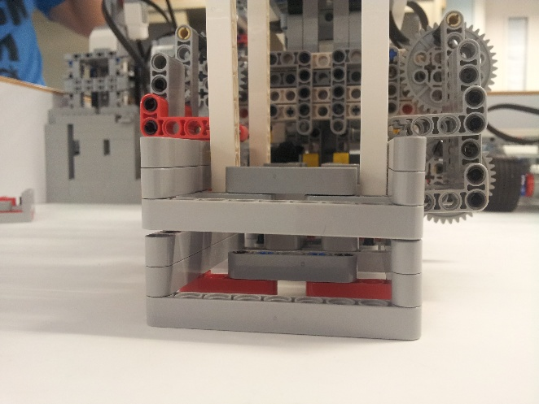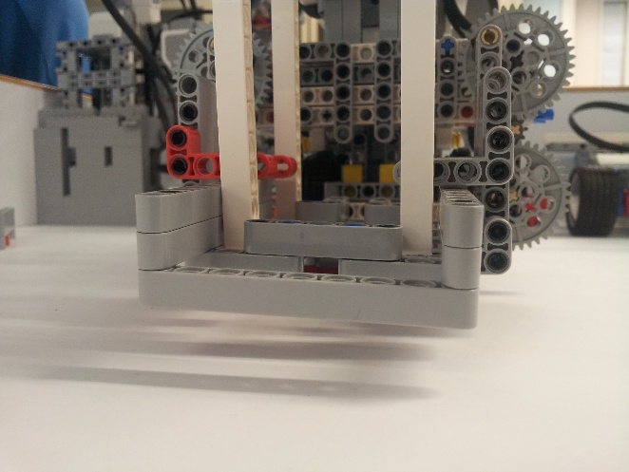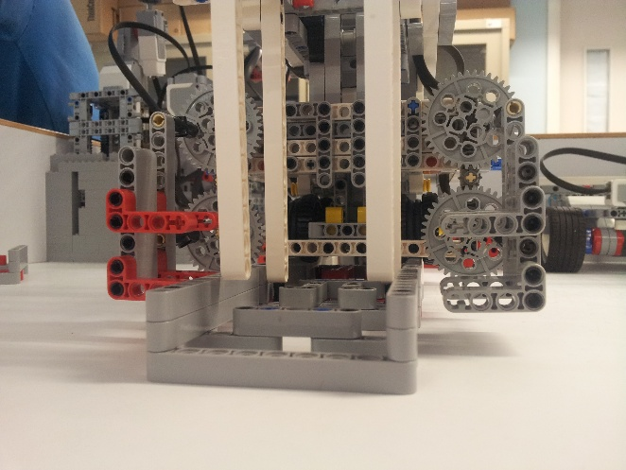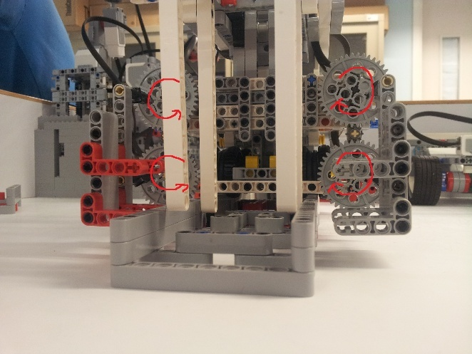The recycle/install railway machine in the front of the Collector

1. When the red turns

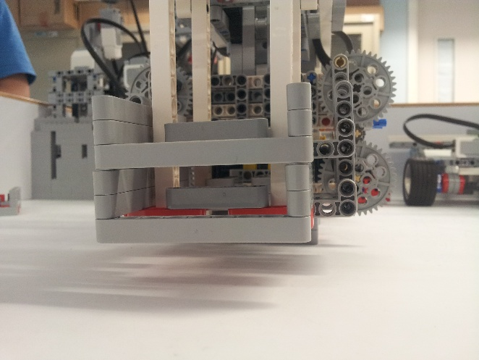2. one railway can be recycled

3. When it turns to another way  
4. Railway will be installed and cocking with the previous railway，

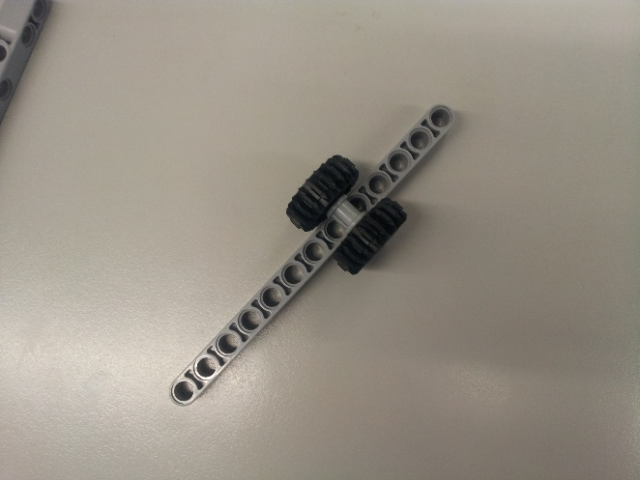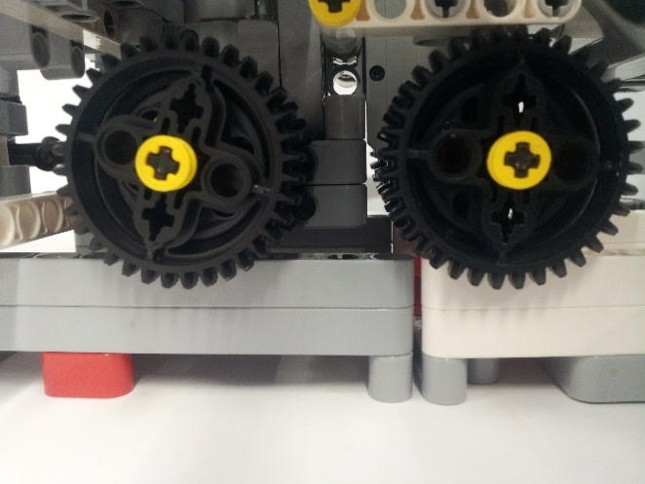

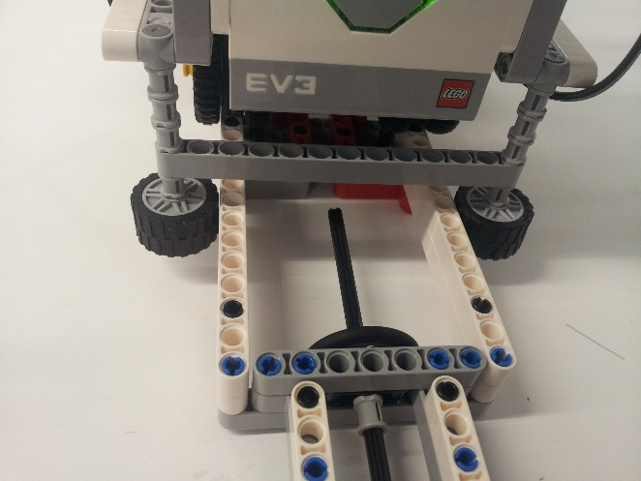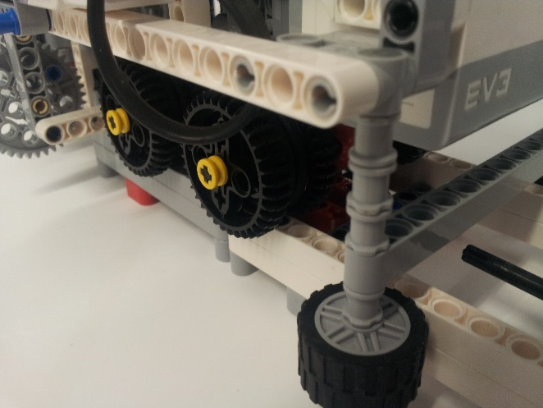The tier of the Collector